Regularized Logistic Regression

We can regularize logistic regression in a similar way that we regularize linear regression. As a result, we can avoid overfitting. The following image shows how the regularized function, displayed by the pink line, is less likely to overfit than the non-regularized function represented by the blue line:

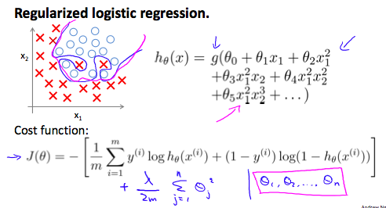

Cost Function

Recall that our cost function for logistic regression was:

